2026 MTHEMATICS PAPER II
PROVISIONAL MARKING KEY

- a) $\frac{4\sqrt{10a}}{3\sqrt{6a}-\sqrt{3a}}$
=$\frac{4\sqrt{10a}}{3\sqrt{6a}-\sqrt{3a}}×\frac{3\sqrt{6a}+\sqrt{3a}}{3\sqrt{6a}+\sqrt{3a}}$ M1
$=\frac{12\sqrt{60a^{2}}+4\sqrt{30a^{2}}}{(3\sqrt{6a})^{2}-(\sqrt{3a})^{2}}$ M1
$=\frac{12×2a\sqrt{15}+4a\sqrt{3}}{9×6a+3a}$ M1
$=\frac{4a(6\sqrt{15}+\sqrt{3})}{57a}$ M1
$=\frac{4(6\sqrt{15}+\sqrt{3})}{57}$ M1 A1

b)
$$S_{n}=n^{2}-3n$$
$S_{1}={(1)}^{2}-3(1)$ M1
$S_{1}=-2$ M1
$S_{2}={(2)}^{2}-3(2)$
$S_{2}=-2$
$S_{1}=T_{1}$
$T_{2}=S_{2}-S_{1}$ M1
$T_{2}=-2-(-2)$
$T_{2}=0$
${d=T}_{2}-T_{1}$ M1
$d=0-(-2)$
$d=2$ M1 A1
Or
$S_{1}={(1)}^{2}-3(1)$ M1
$S_{1}=-2$ M1
$S_{n}=n^{2}-3n$
$\frac{n}{2}\left[2a+\left(n-1\right)d\right]=n^{2}-3n$ M1
$2a+\left(n-1\right)d=\frac{2}{n}(n^{2}-3n)$
$2\left(-2\right)+\left(n-1\right)d=2n-6$
$d(n-1)=2n-6+4$
$d=\frac{2n-2}{n-1}$ M1
$d=2$ M1A1

$r=25cm$ M1
${V_{total}=V}_{cylinder}+V_{hemisphere}$
$V_{total}=πr^{2}h+2/3πr^{3}$
$V_{total}=\frac{22}{7}×25×25×10+2/3×\frac{22}{7}×{(25)}^{3}$ M1
$V_{total}=19642.857142+98214.2857$
$V_{total}=117857.142856$ M1
$Remaining volume= V_{total}-V_{water}$
$Remaining volume= 117857.142856-500$ M1
$Remaining volume=117357.142856$
$V_{remaining}=πr^{2}h$
$117357.142856 =πr^{2}h$
$h=\frac{117357.142856×7 }{22×25×25}$ M1
$h=59.75$cm M1 A1

b) Given that ${Log}_{3}6=1.631$, evaluate ${Log}_{3}0.5$ (5 marks)

${Log}_{3}0.5={Log}_{3}\left( \frac{3}{6} \right)$ M1
${Log}_{3}0.5={Log}_{3}3- {Log}_{3}6$ M1
${Log}_{3}0.5=1-1.631$ M1
${Log}_{3}0.5=-0.631$ M1 A1

- a)
$A=\frac{1}{2}×6×QR×Sin60°$ M1
$2=\frac{1}{2}×6×QR×0.866025$ M1
$QR=\frac{4}{6×0.866025}cm$
$QR=0.769cm$ M1 A1

b)
$\frac{{2t}^{2}-14}{t^{2}-49}=\frac{2t(t-7)}{(t+7)(t-7)}$ M1 M1
$=\frac{2t(t-7)}{(t+7)(t-7)}$ M1
$=\frac{2t}{(t+7)}$ A1

- a)
$n\left(B\right)=50-35$ M1
$p\left(B\right)=\frac{15}{50}$ M1
$p\left(P\right)=\frac{27}{50}$ M1
$p\left(BUP\right)=p\left(B\right)+p\left(P\right)-p(B∩P)$
$p\left(BUP\right)=\left(\frac{15}{50}+\frac{27}{50}\right)-\left(\frac{15}{50}×\frac{27}{50} \right)$ M1
$=\frac{42}{50} -\frac{81}{500}$
$p\left(BUP\right)=\frac{339}{500}$ M1 A1

b)
$\vec{LM}=\vec{LK}+\vec{KN}+\vec{NM}$ M1
$\vec{NP}=\underline{b}$. M1
$\vec{NM}=\frac{3}{2}\underline{b}$. M1
$\vec{LM}=-\underline{b}+\underline{a}+\frac{3}{2}\underline{b}$ M1
$\vec{LM}=\frac{3b-2b+a}{2}$ M1
$\vec{LM}=\frac{1}{2}(\underline{a}+\underline{b})$ A1

- a) Table 1 shows a data set representing the number of chambo caught in a certain lake
recorded on daily basis.
Table 1 M1
Class interval | Number of days | Mid-point
20 – 30 | 4 | 25
31 – 41 | 10 | 36
42 – 52 | 8 | 47
53 – 63 | 16 | 58
64 – 74 | 12 | 69
M1 for the midpoint 47

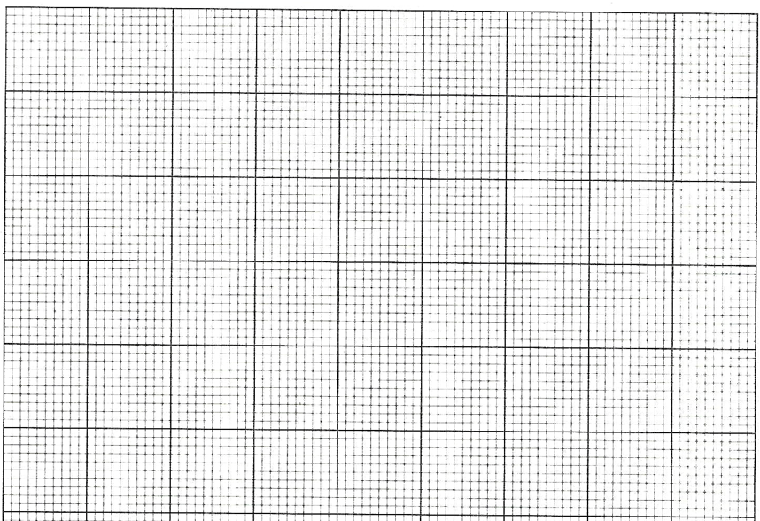

0 4 8 12 16

Frequency

14 25 36 47 58 69 80

Mid-points

M1 correct axes and scale
M1 locating points
M1 joining points
M1 A1 drawing polygon

b) $Type equation here.$
$a=-1, b=3$ M1 $\frac{y}{-1}=x^{2}-3x-4$ M1
$x=\frac{-b}{2a}$ M1 $\frac{y}{-1}=x^{2}-3x+(1.5)^{2}-(1.5)^{2}-4$ M1
$x=\frac{-3}{2(-1)}$ M1 $\frac{y}{-1}=(x-1.5)^{2}-2.25-4$ M1
$x=1.5$ $y=-(x-1.5)^{2}-6.25$ M1
$y={-(1.5)}^{2}+3(1.5)+4$ M1 $T=(1.5,6.25)$ A1
$y=6.25$
$T=(1.5,6.25)$ A1

Or

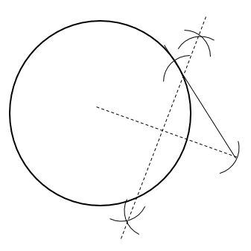
NOT DRAWN TO SCALE

T

O

N

M1 – circle
M1 – point N
M1, M1 – bisector
M1 – point T
M1 – measuring NT
A1 – correct value

$x^{3}+3x^{2}-4x-12=0$ M1
$p\left(x\right)=x^{3}+3x^{2}-4x-12$
$p\left(2\right)={(2)}^{3}+3{(2)}^{2}-4(2)-12$ M1
$p\left(2\right)=0$
$Thus \left(x-2\right)is a factor$ M1

$x^{2}+5x+6$ M1 M1
$x-2$ $x^{3}+3x^{2}-4x-12$
$-x^{3}-2x^{2}$
$5x^{2}-4x$
$-5x^{2}-10x$
$6x-12$
$-6x-12$
$0$

$x^{3}+3x^{2}-4x-12=0$
$\left(x-2\right)\left(x^{2}+5x+6\right)=0$ M1
$\left(x-2\right)\left(x+2\right)(x+3)=0$ M1
$∴x=2,or x=-2, or x=-3$ A1 A1 A1

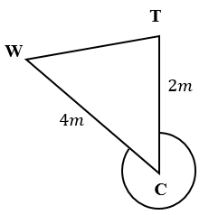
$Sketch$
$Φ$ M1

$θ$
$300°$
$θ=360°-300°$ M1
$θ=60°$
$d^{2}=2^{2}+4^{2}-2\left(2\right)\left(4\right)Cos60°$ M1
$d^{2}=4+16-16(0.5)$ M1
$d^{2}=20-8$
$d=\sqrt{12}$ M1
$d=3.4641$m A1

$\frac{d}{Sinθ}=\frac{4}{SinΦ}$ M1
$\frac{3.4641}{Sin60° }=\frac{4}{SinΦ}$
$SinΦ=\frac{4Sin60}{3.4641}$
$SinΦ=1$
$Φ=Sin^{-1}1$
$Φ=90°$ M1
$∴bearing=180°+90°=270°$ A1

$Let p=price, n=number of mangoes$
$p=K+An^{2}$ B1
$7000=K+A{(8)}^{2}$ M1
$7000=K+64A$ M1

$8700=K+A{(9)}^{2}$
$8700=K+81A$

$8700=K+81A$ M1
$-7000=K+64A$
$1700=17A$ M1
$A=100$

$8700=K+81(100)$ M1
$8700=K+8100$ M1
$K=600$

$p=600+100n^{2}$ M1

$p=600+100{(11)}^{2}$ M1
$p=600+12100$
$p=12,700$ A1

$y={2x}^{2}-3x+1$
x | -2 | -1 | 0 | 1 | 2 | 3 | 4
y | 15 | 6 | 1 | 0 | 3 | 10 | 21
B1 B1

- Complete the table by filling in the missing values. (2 marks)

- On the graph paper
M1 correct scale
M1 locating points on a curve or straight line
M1 Joining points on a curve
M1 joining points on a straight line
M1 intersection points

- Use the table to plot the graph of the equation$y={2x}^{2}-3x+1$. Use the scale
${y=2x}^{2}-3x+1=2-2x$ $y=2-2x$ M1
Table of values for $y=2-2x$
x | -1 | 0 | 1
y | 4 | 2 | 0

$x=-0.6 or x=1$

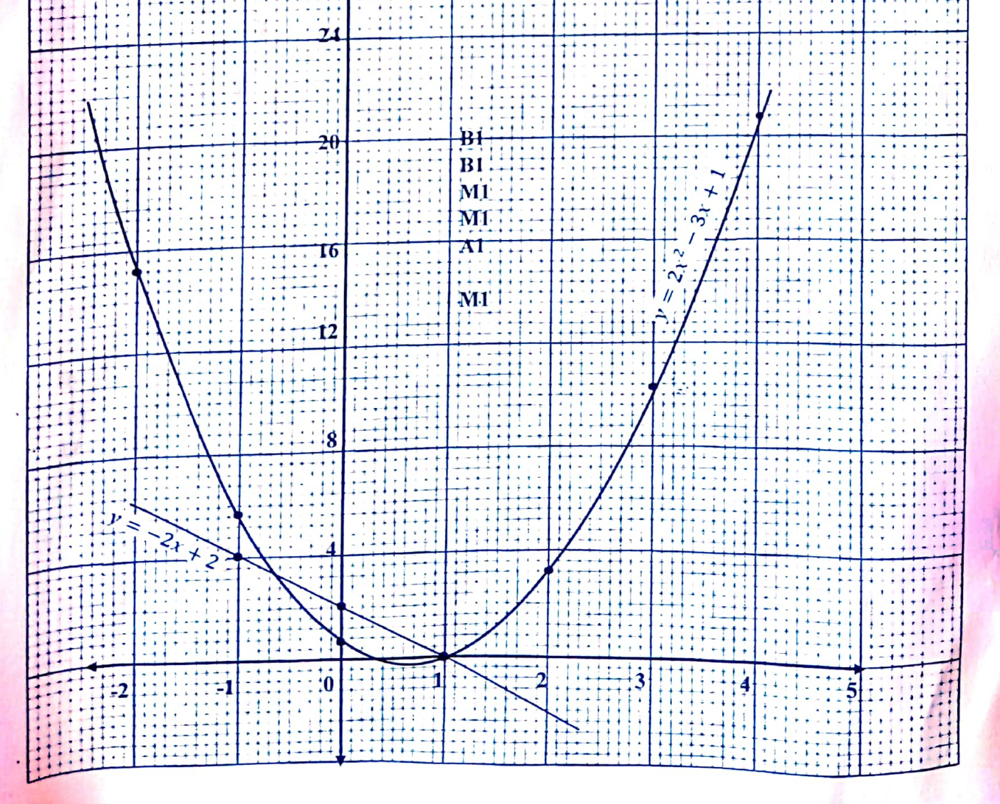

- PM pass Math, FM fail Math; PP pass Physics, FP fail Physics; PC pass Chemistry, FC fail chemistry
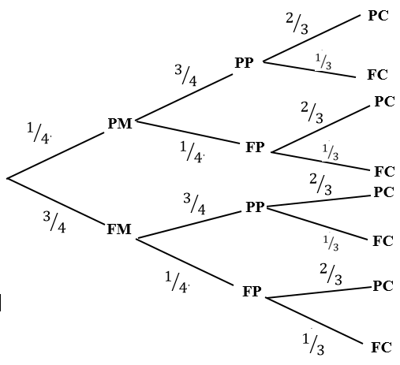

M1, M1, M1, M1, A1( 5 marks for tree diagram)

$p\left(selection\right)=PM,PP,PC∪PM,PP,FC∪PM,FP,PC∪FM,PP,PC$ M1
$p=(1/4×3/4)×(2/3+1/4)×(3/4×1/3)+(1/4×1/4)×(2/3+3/4×3/4×2/3$ ) M1
$p=6/{48}+3/{48}+2/{48}+{18}/{48}$ M1
$p={29}/{48}$ M1 A1
$p=0.6042$

- $Let x=mother^{'}s age y=daughter^{'}sage$
$x=2y$ M1
$\left(x+5\right)\left(y+5\right)=1125$ M1
$\left(2y+5\right)\left(y+5\right)=1125$ M1
${2y}^{2}+10y+5y+25=1125$ M1
${2y}^{2}+15y+25=1125$
${2y}^{2}+15y+25-1125=0$
${2y}^{2}+15y-1100=0$
${2y}^{2}+55y-40y-1100=0$
$y(2y+55)-20(2y-55)=0$ M1
$(2y+55)(y-20)=0$ M1
$y=-55 or y=20$ M1

Therefore $y=20$ and x = 2(20) M1
Daughter’s age = 20, mother’s age = 40 years A1 A1

